Reference：<https://developer.amazon.com/alexa-skills-kit/alexa-skill-quick-start-tutorial>

Step 1: Sign in to Amazon Web Services (AWS) and create a function

Step 2: Use the Amazon developer portal to configure your skill

Here we list several changes when using our skill and costumer functions:

Step 2.8 : **Open OUR file named intent_schema.json.** In the **Intent Schema** box, paste **OUR** JSON code.

Step 2.10 : **Open OUR file named custom_slot_types.txt, where** we list several SLOTS name there. Copy one slot name and paste it in the **Enter type**, and enter its values listed below the slot name in our file.

Step 2.11 : Choose **Add**. If there is additional SLOT listed in our file, then Choose **Add Slot Type**, repeat the previous steps.

Step 2.12 : **OPEN OUR FILE named sample_utterances.txt** and copy the **Utterances into** under **Sample Utterances**.

After all Steps in Step 1 and 2, then modify the function according the following step:

1. Log in to the [AWS Management Console](https://aws.amazon.com/).
2. From the list of services, select **Lambda**.
3. In the list of function name, choose the one built in step 1.

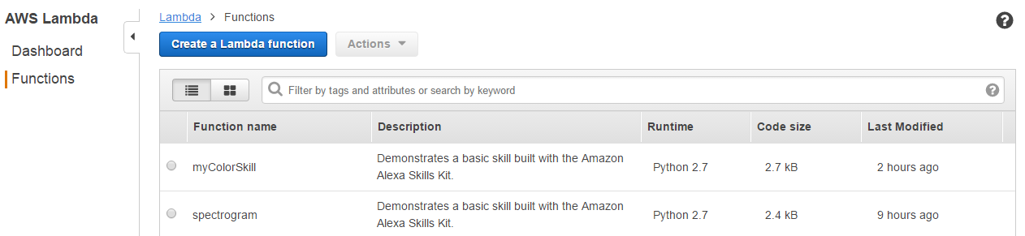

1. **Open our file named lambda.py.** Copy the codes into the coding area, then **save** it.

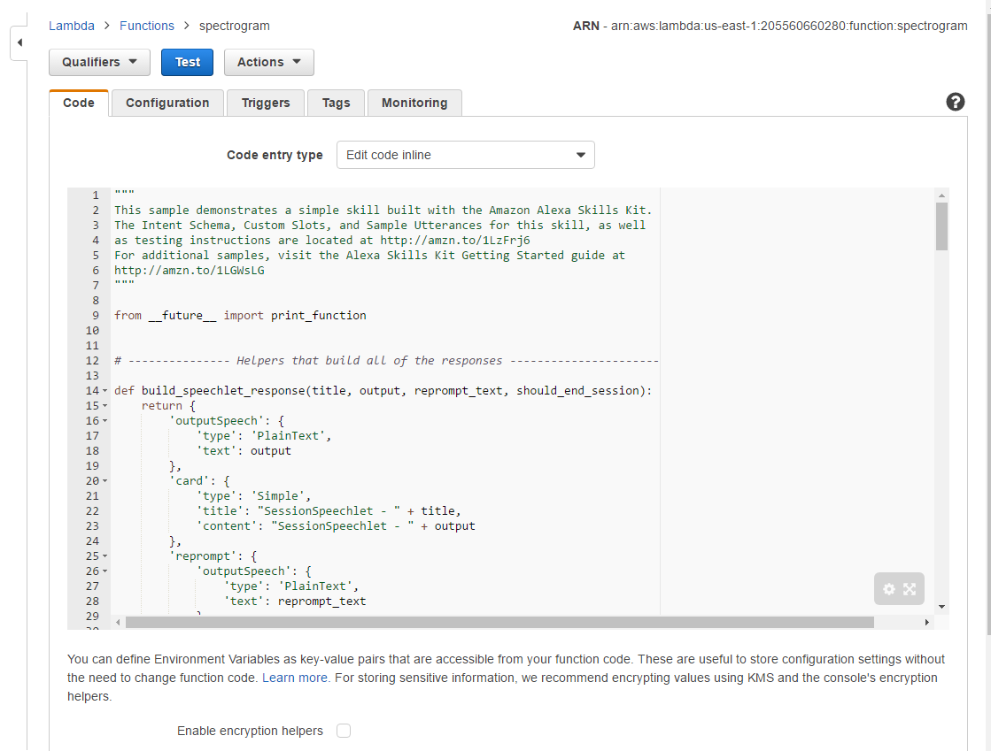

1. Finish Step 3 on the website.